# Pedro and the Octopus

## Tactile Literacy Teaching Guide

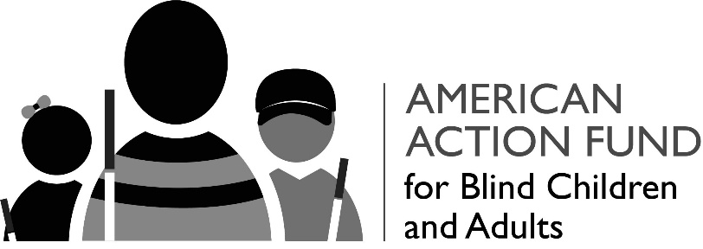

Published by the American Action Fund for Blind Children and Adults®, a nonprofit that supports programs for the blind and deaf-blind in the United States. For more information, call 410-659-9315 or write to:

American Action Fund for Blind Children and Adults

1800 Johnson Street

Baltimore, Maryland 21230

Copyright © 2019 by American Action Fund for Blind Children and Adults

## Introduction:

*Pedro and the Octopus* is a TwinVision® book commissioned by the American Action Fund for Blind Children and Adults®. This book includes text in print and Braille, as well as pictures that have both color and tactile features. This allows the book to be enjoyed by everyone—blind or sighted —at the same time. This book is meant to help build tactile fluency—understanding through touch. Developing this skill helps facilitate engaged learning in ways that text description alone cannot achieve.

The questions in this guide can be used by parents and educators to encourage active exploration of the tactile pictures. The more experience blind children can acquire with tactile exploration, the better they will be able to detect patterns, recognize details, and thus interpret information that is presented tactilely.

Your feedback about the book and this guide are helpful to our continued investigation of tactile fluency. We welcome stories about those who have benefited from experiencing the book. We also invite your suggestions for future projects. Please send us your thoughts at [actionfund@actionfund.org](mailto:actionfund@actionfund.org).

### Pedro and Lena on the Beach

Find Lena on the left and Pedro on the right. Both kids are holding something. Who is holding the pail? Which one is holding a long white cane? What does Lena have on her swimsuit?

Pedro is waving to us. Can you find his hand in the air? What do you see in the sky?

Now look at the bottom of the picture. Which is the ocean, and which is the sand?

### Footprints and cane prints

Can you feel the footprints Pedro left in the sand? Can you count all ten toes? How many cane prints do you find?

Where is the ocean now?

### Pebbles and stones

How many stones can you find on this beach? How many are rough and how many are smooth? Which is your favorite?

Can you find the waves lapping at the sand? Sea foam dances on the edge of the waves.

### Seashells

Can you count the seashells on the sand? Some seashells have ridges, some are spirals, some are smooth, and some are bumpy. Which one is your favorite?

### Crab

Find all ten legs on this crab. Where are his eyes? Can you find his two claws? They can pinch!

### Footprints washing away

Find Pedro’s foot prints. Can you see the fish in the ocean? A shell called a Cat Paw is resting on the sand behind his footprints.

### Pedro and Lena in the waves

Where is Pedro’s cane?

Who has both hands in the air?

Find the sailboat far out on the ocean. What do you see in the sky?

### A sandwich and cookies

Can you feel the difference between the towel and the sand?

How many cookies are there on the plate? What was used to cut the sandwich? Can you find it in this picture?

### Shells, crab, and stone

What treasures did Pedro have in his pail? Can you find the sand on the towel? Look for the seaweed. It has leaves.

### Octopi with a lot of arms

How many octopi can you find? Look at all those arms!